Tuning (or Approximating)
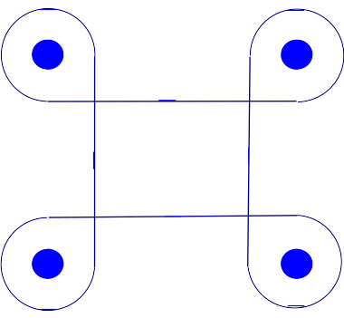
The goal is to drive a car in a clover leaf pattern like that to the right.

Build a car. Taxi-Taxi is quick and easy. Arctic Ride or Big Little Helper also work. Basic requirement is to have two motors pushing the car so that it can turn.

Use only the parts in your kit or the extra parts kit. If a part is missing ask for help. Do not raid another kit for parts.
Pseudo code or fake code is just a way of expressing the concept of the code without writing the code itself. The pseudo code for this project is:

loop 4 times:
drive straight
do a 270° outside turn

The “drive straight” part is shown on the right. This block controls both motors so that the car mores forward. (It the car moves backward either 1) reverse the connections to the hub or 2) change the direction of the arrow in the block.

You do need to “tune” the distance of the straight line. Try a value. If it is too short, make it longer. If it is too long, make it shorter. When you get to a point where one guess is too long and one is too short, you know that the value is between the two. Select a value between and then see if it is too long or too short and then pick another value until you get the right value.

Example: suppose you want to find the decimal value of 5/3 and you don’t know how to divide, but you know that it is the same thing as finding the number that when multiplied by 3 results in 5.

Value to try | Compute answer | Compute Error | Comment
1 | 3 x 1 = 3 | Error = 5 - 3 = 2 | Too low, try bigger
2 | 3 x 2 = 6 | Error = 5 - 6 = -1 | Too high, try smaller
1.5 | 3 x 1.5 = 4.5 | Error = 5 - 4.5 = 0.5 | Too low, try bigger
1.7 | 3 x 1.7 = 5.1 | Error = 5 - 5.1 = -0.1 | Too high, try smaller
1.6 | 3 x 1.6 = 4.8 | Error = 5 - 4.8 = 0.2 | Too low, bigger error, try between
1.65 | 3 x 1.65 = 4.95 | Error = 5 - 4.95 = 0.05 | Still too low, but close, try bigger
1.66 | 3 x 1.66 = 4.98 | Error = 5 - 4.98 = 0.02 | Getting close enough
1.67 | 3 x 1.67 = 5.01 | Error = 5 – 5.01 = -0.01 | Too high, but closer yet


The “outside turn” part starts out like (in an outside turn, you turn opposite the direction that you really want to make):

Adjust the first parameter to get the desired turn direction and radius (smaller values make wider turns; bigger values make tighter turns).

Adjust the second parameter so that the resulting turn is square. You may need to use decimal fractions to get a “better” answer.

These two parameters interact with each other, so you will need to work back and forth between the two until you get the desired result.
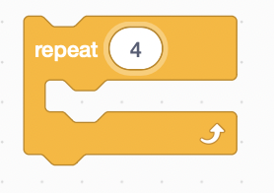
Now that you have the straight part and the turn part done, put these two blocks inside a repeat loop block. Because you are repeating a movement based on a common setting, the errors may add like in the turn or may subtract like in the distance. Adjust the parameters as needed.

Try to see if you can move the car to its initial starting position without hitting the cones marking the centers of the clover leaf turns.

Now change the movement to move through the exercise faster.

Make it work—Make it fast—Make it right!

